**Lesson08 Understanding ViewContainerRef in Angular 2**

**Notes:-**

**1-If you ever needed to insert new component or template programmatically, you probably used the ViewContainerRef service.**

**2-When you need to add new DOM element (i.e., component, template) you need a place to insert the element.**

**3-We are injecting the service in the component. In this case, the container will refer to your host element (the vcr element) and the template will be inserted as a sibling of the vcr element.**

**Example:-**

**We want to insert template inside another component like the following:-**

**1-on the TestingCompComponent we do the following code**

import { Component, OnInit, ViewChild, ViewContainerRef } from '@angular/core';

@Component({

selector: 'app-testing-comp',

template:

//assign ng-template element inside div with reference variable container

'<ng-template #tpl>' +

'<h1>ViewContainerRef</h1>' +

'</ng-template>' +

'<div>Some element</div>' +

'<div #container></div>',

styleUrls: ['./testing-comp.component.css']})

export class TestingCompComponent {

@ViewChild('container', { read: ViewContainerRef }) _vcr;

@ViewChild('tpl') tpl;

//after the view rendering we insert template with reference variable #tp1

//inside the div with reference variable #container

ngAfterViewInit() {this._vcr.createEmbeddedView(this.tpl);}}

**2-on the app.component.ts we set the following code**

//on the app.component.ts we set the following code

@Component({

selector: 'my-app',

templateUrl: './app.component.html'})

export class App {}

**3-we see that the ng-template inserted inside the div with reference variable container**

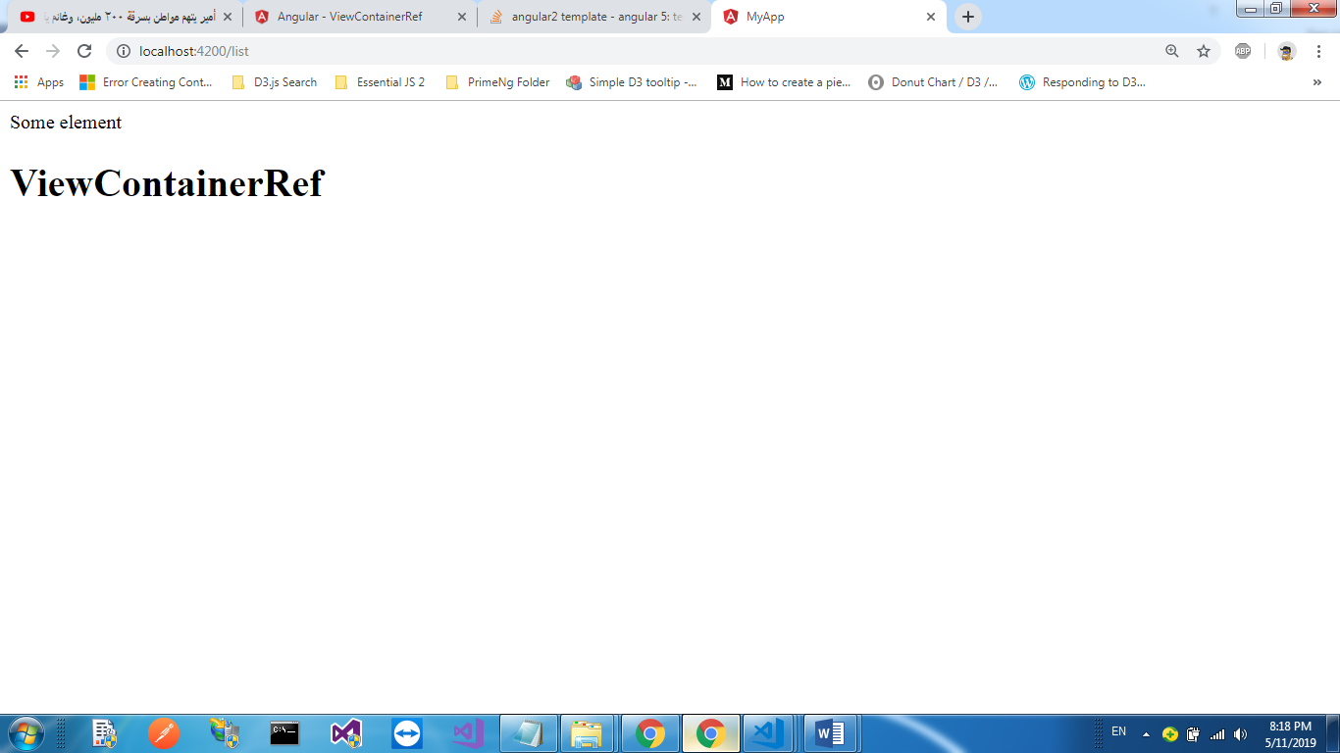

**ViewContainerRef :-**

**1-Can contain host views**

**(created by instantiating a component with the createComponent() method),**

**And embedded views**

**(created by instantiating a TemplateRef with the createEmbeddedView() method).**

**Methods**

**1-createEmbeddedView()**

**Instantiates an embedded view and inserts it into this container.**

abstract createEmbeddedView<C>(templateRef: TemplateRef<C>, context?: C, index?: number): EmbeddedViewRef<C>

Parameters

|  |  |  |
| --- | --- | --- |
| **templateRef** | [TemplateRef](https://angular.io/api/core/TemplateRef) | The HTML template that defines the view. |
| **context** | C | Optional. Default is undefined. |
| **index** | number | The 0-based index at which to insert the new view into this container. If not specified, appends the new view as the last entry.  Optional. Default is undefined. |

Returns

[EmbeddedViewRef<C>](https://angular.io/api/core/EmbeddedViewRef): The [ViewRef](https://angular.io/api/core/ViewRef) instance for the newly created view.

**2-Get(index:number)**

**Retrieves a view from this container.**

|  |
| --- |
| Retrieves a view from this container. |
| abstract get(index: number): ViewRef | null  Parameters   |  |  |  | | --- | --- | --- | | **index** | number | The 0-based index of the view to retrieve. |   Returns  [ViewRef](https://angular.io/api/core/ViewRef) | null: The [ViewRef](https://angular.io/api/core/ViewRef) instance, or null if the index is out of range. |

**3-Clear()**

**Destroys all views in this container.**

|  |
| --- |
| Retrieves a view from this container. |
| abstract get(index: number): ViewRef | null  Parameters   |  |  |  | | --- | --- | --- | | **index** | number | The 0-based index of the view to retrieve. |   Returns  [ViewRef](https://angular.io/api/core/ViewRef) | null: The [ViewRef](https://angular.io/api/core/ViewRef) instance, or null if the index is out of range. |

**4-createComponent()**

**Instantiates a single component and inserts its host view into this container.**

|  |
| --- |
| Instantiates a single component and inserts its host view into this container. |
| abstract createComponent<C>(componentFactory: ComponentFactory<C>, index?: number, injector?: Injector, projectableNodes?: any[][], ngModule?: NgModuleRef<any>): ComponentRef<C>  Parameters   |  |  |  | | --- | --- | --- | | **componentFactory** | [ComponentFactory](https://angular.io/api/core/ComponentFactory) | The factory to use. | | **index** | number | The index at which to insert the new component's host view into this container. If not specified, appends the new view as the last entry.  Optional. Default is undefined. | | **injector** | [Injector](https://angular.io/api/core/Injector) | The injector to use as the parent for the new component.  Optional. Default is undefined. | | **projectableNodes** | any[][] | Optional. Default is undefined. | | **ngModule** | [NgModuleRef](https://angular.io/api/core/NgModuleRef) | Optional. Default is undefined. |   Returns  [ComponentRef<C>](https://angular.io/api/core/ComponentRef): The new component instance, containing the host view. |

**5-insert()**

**Inserts a view into this container.**

|  |
| --- |
| Inserts a view into this container. |
| abstract insert(viewRef: ViewRef, index?: number): ViewRef  Parameters   |  |  |  | | --- | --- | --- | | **viewRef** | [ViewRef](https://angular.io/api/core/ViewRef) | The view to insert. | | **index** | number | The 0-based index at which to insert the view. If not specified, appends the new view as the last entry.  Optional. Default is undefined. |   Returns  [ViewRef](https://angular.io/api/core/ViewRef): The inserted [ViewRef](https://angular.io/api/core/ViewRef) instance. |

**6-** **move()**

**Moves a view to a new location in this container.**

**abstract move(viewRef: ViewRef, currentIndex: number): ViewRef**

|  |  |  |
| --- | --- | --- |
| **viewRef** | [ViewRef](https://angular.io/api/core/ViewRef) | The view to move. |
| [**currentIndex**](https://angular.io/api/core/IterableChangeRecord#currentIndex) | number |  |

**7-** **indexOf()**

**Returns the index of a view within the current container.**

abstract indexOf(viewRef: ViewRef): number

Parameters

|  |  |  |
| --- | --- | --- |
| **viewRef** | [ViewRef](https://angular.io/api/core/ViewRef) | The view to query. |

Returns

number: The 0-based index of the view's position in this container, or -1 if this container doesn't contain the view.

**8-remove()**

|  |
| --- |
| Destroys a view attached to this container |
| abstract remove(index?: number): void  Parameters   |  |  |  | | --- | --- | --- | | **Index** | number | The 0-based index of the view to destroy. If not specified, the last view in the container is removed.  Optional. Default is undefined. |   Returns  Void |

**9-** **detach()**

| [mode_edit](https://github.com/angular/angular/edit/master/packages/core/src/linker/view_container_ref.ts?message=docs(core)%3A%20describe%20your%20change...#L138-L145)[code](https://github.com/angular/angular/tree/7.2.15/packages/core/src/linker/view_container_ref.ts#L138-L145) |
| --- |
| Detaches a view from this container without destroying it. Use along with [insert()](https://angular.io/api/forms/FormArray#insert) to move a view within the current container. |
| abstract detach(index?: number): ViewRef | null Parameters  |  |  |  | | --- | --- | --- | | **index** | number | The 0-based index of the view to detach. If not specified, the last view in the container is detached.  Optional. Default is undefined. |  Returns [ViewRef](https://angular.io/api/core/ViewRef) | null |